New Patient | Column: HYG (Ambler, Cherry Hill, West Philly) or NEW (Allegheny or Northeast)  ProvID: NEW  Reason: Initial – NP Child NoX  30 minutes  Allegheny, Northeast, West Philly have 15-minute blocks instead of 10-minute blocks. Make sure to schedule for 30 minutes.  Allegheny – Found on Hygiene schedule.  Only for patients who have not been seen by any of our brands before. Even if a child has not been seen in several years, they are not a new patient.  Ask probing questions  - “Are you calling for general dentistry or orthodontics?”  - “Have any of your children been to any of our offices before?”  - “Has the child had a cleaning in the last six months?”  - “What kind of PDA - Insurance does the child have?”  - If the insurance provided is not in network, advise the caller that the insurance is not in network and treatment would not be covered under in-network benefits.  - We offer a new patient special of $99 (not for referrals or 2nd opinions). This includes a full comprehensive exam, cleaning, fluoride, and x-ray. An ABN (Advance Beneficiary Notice) must be signed by the parent prior to services being rendered. This form states that they are responsible for all costs.  - Any other questions on payments should be directed to the office. If unable to reach the office, send an AIF.  - Probe if the patient is being referred. If they are, schedule as a 2nd opinion.  Parent / legal guardian must be present at the first appointment. If the legal guardian is not the parent, physical court documentation must be with them at the time of the visit.  New Patient Paperwork will be sent to their email on file and as a text link in NexHealth. If they do not complete it prior to the appointment, they must arrive 20-30 minutes early to complete it in office.  If the new patient is having an emergency, schedule as an emergency instead of new patient.  Schedule siblings side-by-side when possible. If the patient has special needs, include a note of any conditions requests for accommodations.  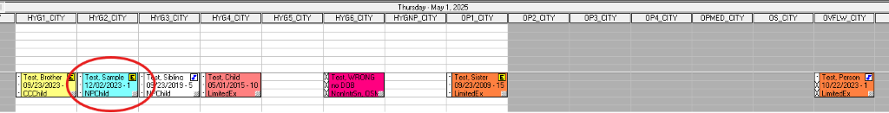

OWM | Column: OWM (Allegheny, Cherry Hill, or Northeast) or HYG (Ambler, Cherry Hill if OWM is full)  ProvID:  - OWM / Babywellness  - Allegheny Only: New OWM patients ProvID: NEW  Reason: Initial – RC Child NoX or Initial – NP Child NoX  Allegheny, Northeast, West Philly have 15-minute blocks instead of 10 minute blocks. Make sure to schedule for 30 minutes.  Allegheny – Found on Hygiene schedule.  - For children ages 4 years old and younger.  - Allegheny for new patient children 5 years old and younger.  - Make sure the patient will not be 5 years old by the time of their appointment. (Exception: Allegheny)  If there is an alert “always OWM” then schedule OWM regardless of age.  In Allegheny, Northeast, and Cherry Hill, schedule in their own column for new and existing hygiene appointments.  - Cherry Hill does allow OWM in HYG if the OWM column is full.  - Do not schedule OWM in Cherry Hill after 3:00 PM.  Not used in West Philly; schedule normally regardless of age.

